First explorations.
I start looking to successful trials with no re-entries.
I first count how many target reaching times fall into the different type of movements.
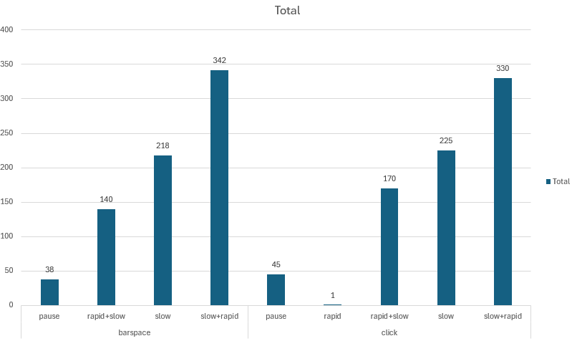
It is weird to me the Pause ones, I will need to check how this are being done. Possibly it is done in a very slow movement. To confirm this I see the count taking into account the width.
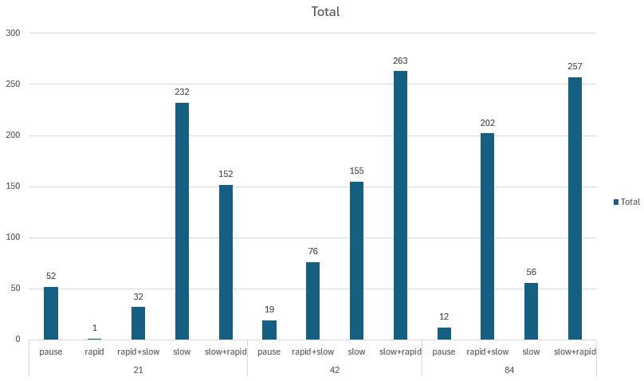
We see that for 21 pixels width, most of the reaching times occur under slow followed by pause movement types. This trend changes, as expected, with larger targets. I do not see any difference discriminating by indication type. Although there is a change if we take only the trials with one reaching time (meaning no outs
It seems to be a difference using feedback with and without buffer.

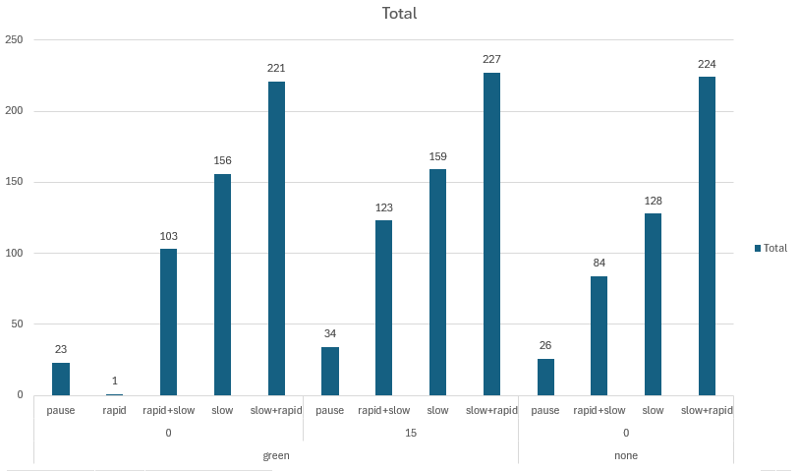

If I go per re entries, with one re entries slow ones have more predominance.
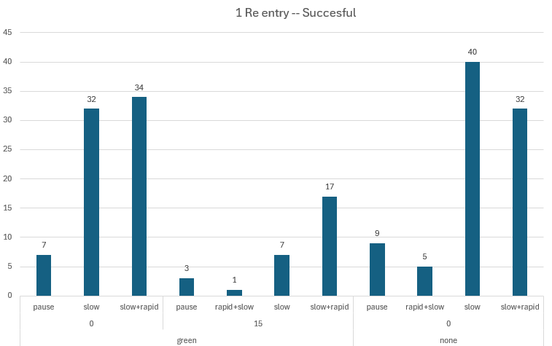

Probably

